Title:
Create an image from running container.
Objective:
To create a new Docker image from an existing running container in order to preserve its current state, configurations, and changes.
Step by step Implementation:
Step 1: Pull NGINX image
docker pull nginx:latest
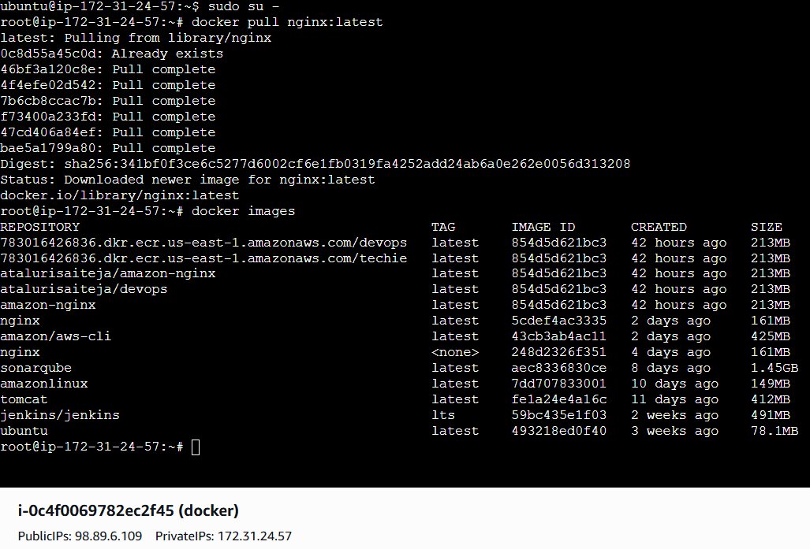

Step 2: Run NGINX container
docker container run -itd -p 8080:80 --name nginx-container nginx:latest
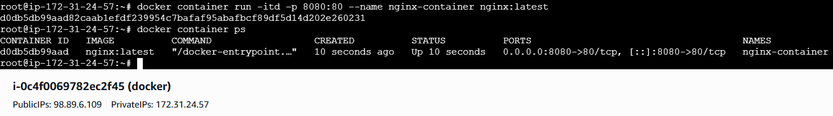
Step 3: Enter running container
docker exec -it nginx-container /bin/bash
Step 4: Modify NGINX default page
echo "<h1>NGINX Image Created from Running Container</h1>" >
/usr/share/nginx/html/index.html
exit
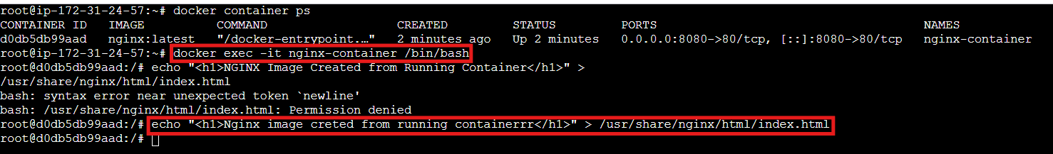
Step 5: Create image from container
docker commit nginx-container custom-nginx:v1
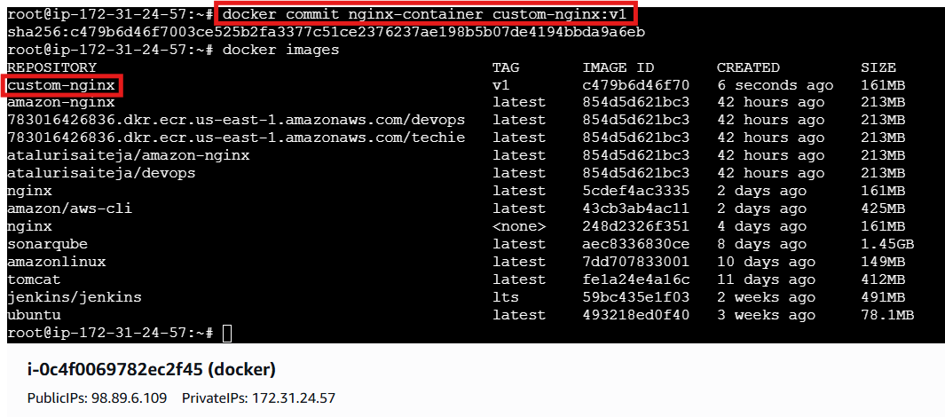
Validation:
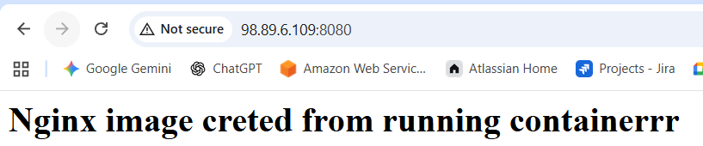
Conclusion:
By committing the running container to a Docker image, the environment can be easily reused, shared, or redeployed without repeating the original setup steps.
Title:
Create Docker image using alpine and customize with tomcat.
Objective:
To create a lightweight Docker image using Alpine Linux and customize it by installing and configuring Apache Tomcat for running Java web applications.
Step by step implementation
Mkdir alpine-tomcat
Cd alpine-tomcat
Vi Dockerfile
FROM alpine:3.19
# Install Java and required tools
RUN apk add --no-cache openjdk11 wget tar bash
# Set working directory
WORKDIR /opt
# Download and extract Tomcat (YOUR URL)
RUN wget https://dlcdn.apache.org/tomcat/tomcat-9/v9.0.115/bin/apache-tomcat-9.0.115.tar.gz \
&& tar -xzf apache-tomcat-9.0.115.tar.gz \
&& mv apache-tomcat-9.0.115 tomcat \
&& rm apache-tomcat-9.0.115.tar.gz
# Expose Tomcat port
EXPOSE 8080
# Start Tomcat
CMD ["/opt/tomcat/bin/catalina.sh", "run"]
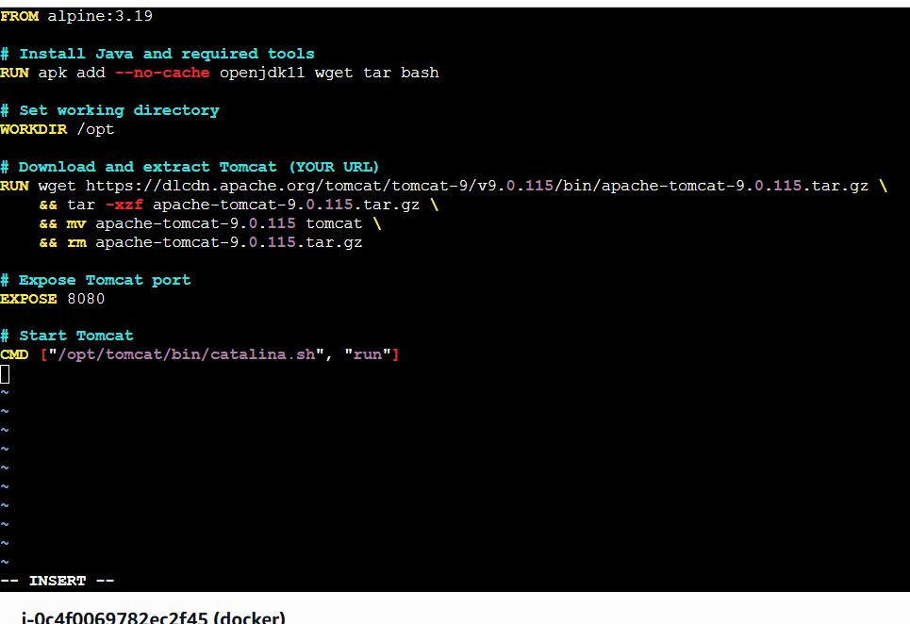
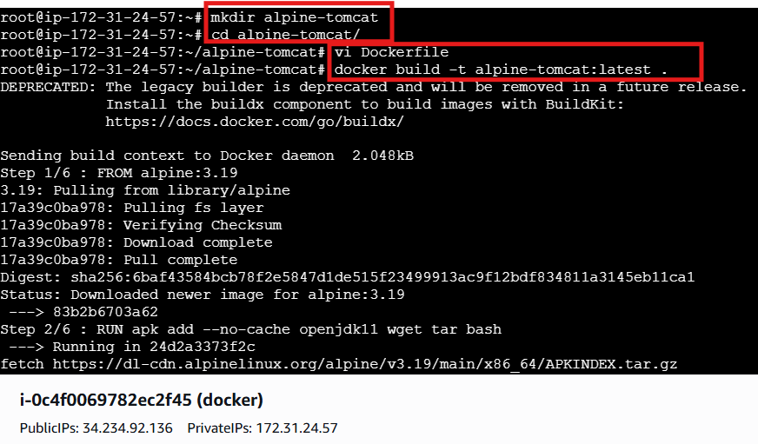

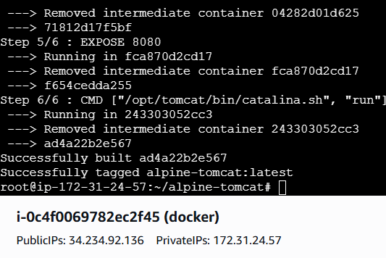
Docker images
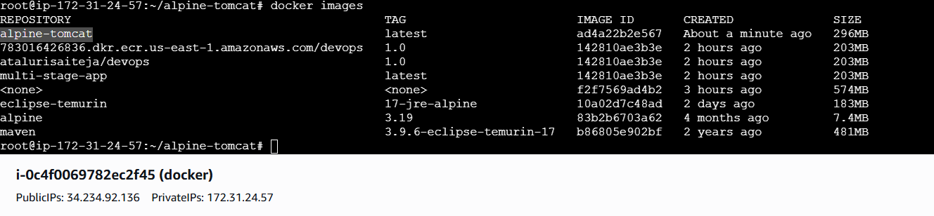
Run container
docker run -d -p 8080:8080 --name tomcat alpine-tomcat:latest
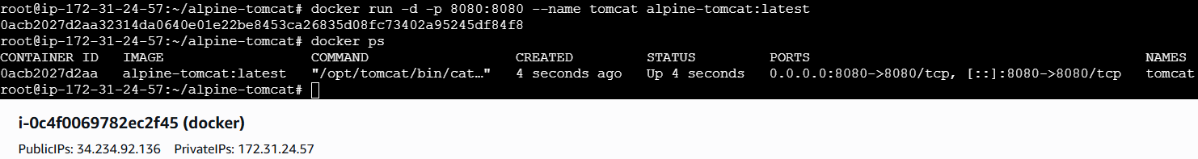
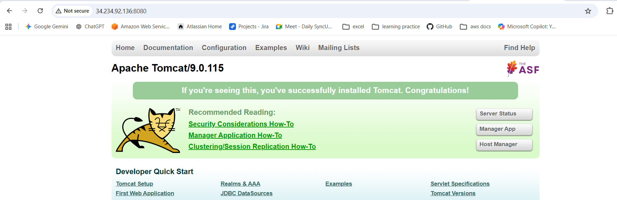
Conclusion:
Using Alpine as the base image results in a smaller, efficient Docker image, and integrating Tomcat provides a ready-to-use environment for deploying and running Java applications in a containerized setup.
Create single stage and multi stage docker file using this source code: https://github.com/betawins/multi-stage-example.git
Objective
- To understand how single-stage and multi-stage Dockerfiles work
- To compare image size and efficiency between both approaches
- To apply Docker best practices for building containerized applications
Step By Step Implementation
Step 1: Clone repository
git clone https://github.com/betawins/multi-stage-example.git
cd multi-stage-example
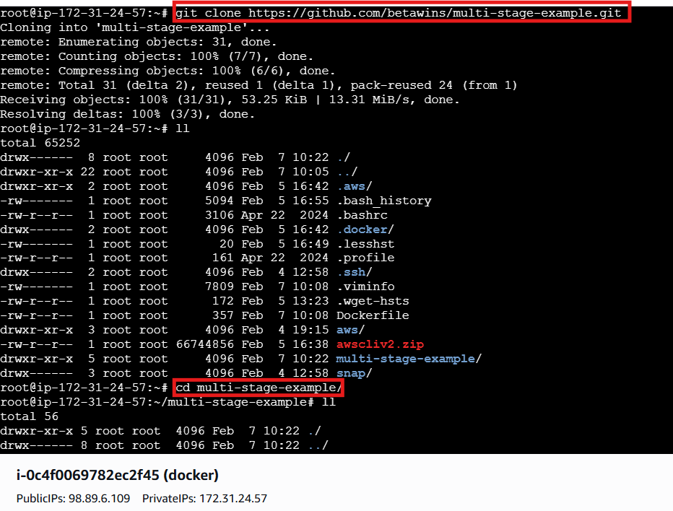
Vi Docker file.single
And paste
FROM maven:3.9.6-eclipse-temurin-17
WORKDIR /app
COPY . .
RUN mvn clean package -DskipTests
EXPOSE 8080
CMD ["java","-jar","target/multi-stage-example-0.0.1-SNAPSHOT.jar"]

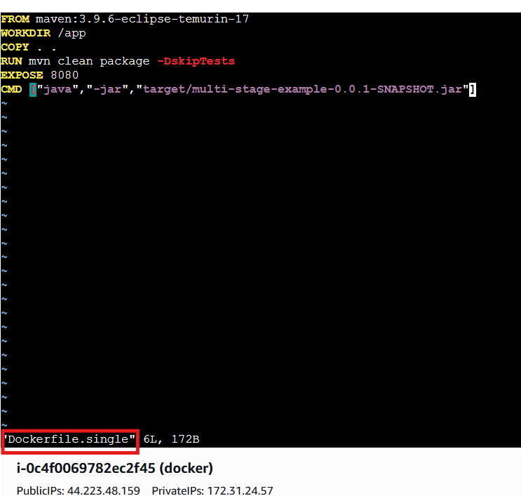
Build single-stage image
docker build -f Dockerfile.single -t single-stage-app .
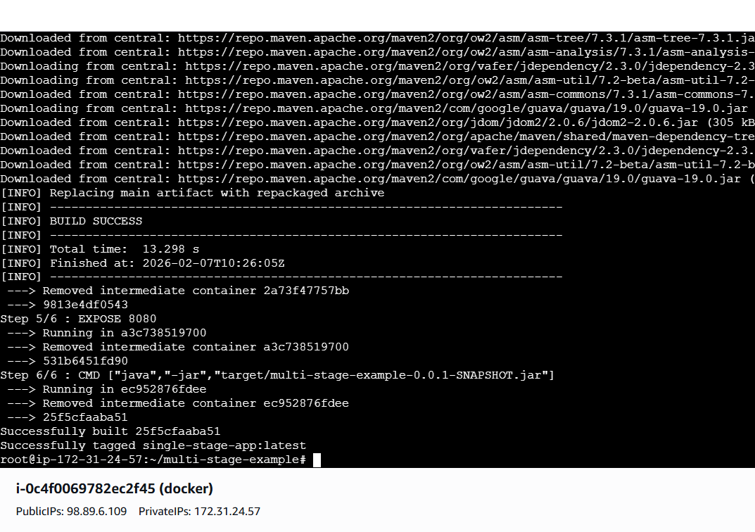
Run single-stage container
docker run -d -p 8081:8080 --name single-stage single-stage-app
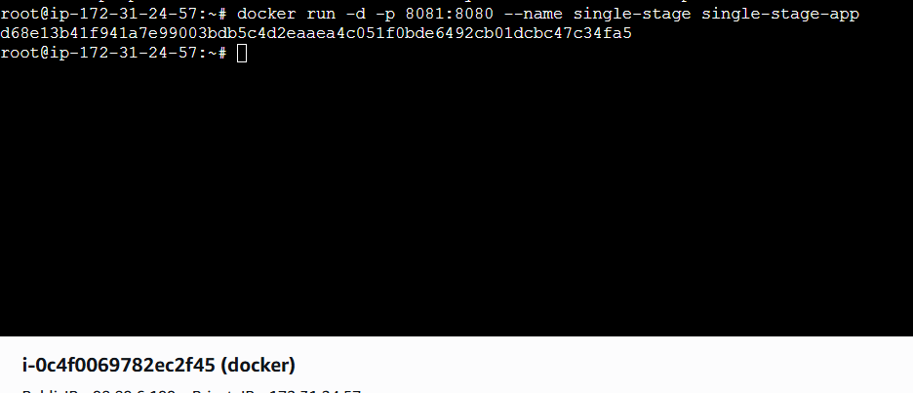
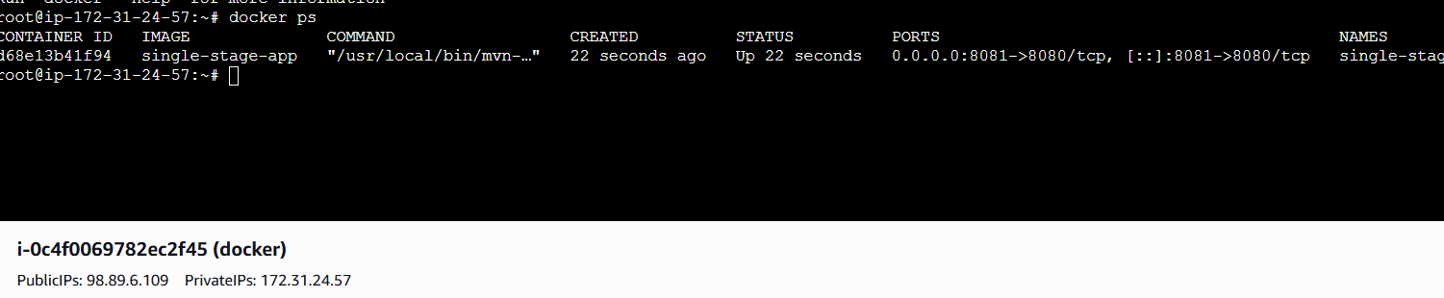

Validation:
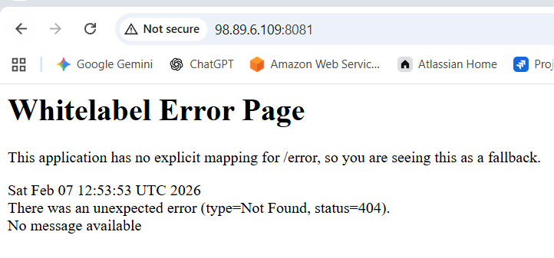

Multi-Stage Dockerfile
vi Dockerfile.multi
FROM maven:3.9.6-eclipse-temurin-17 AS builder
WORKDIR /app
# Copy pom first to cache dependencies
COPY pom.xml .
RUN mvn dependency:go-offline
# Copy source code
COPY src ./src
RUN mvn clean package -DskipTests
FROM eclipse-temurin:17-jre-alpine
WORKDIR /app
# Copy jar from builder stage
COPY --from=builder /app/target/*.jar app.jar
# Expose application port
EXPOSE 8083
CMD ["java","-jar","app.jar"]
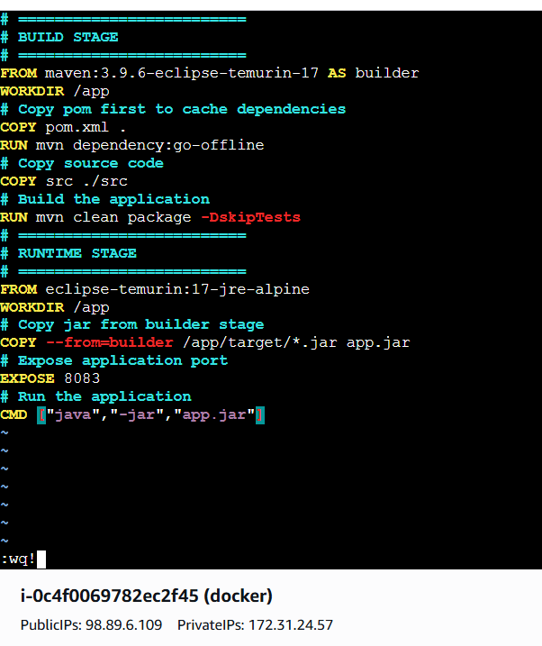

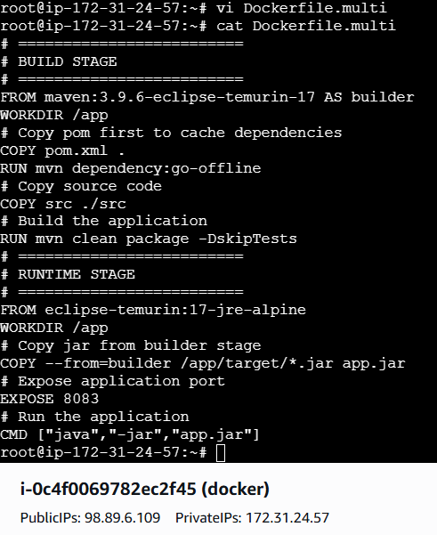
Build multi-stage image
docker build -f Dockerfile.multi -t multi-stage-app .
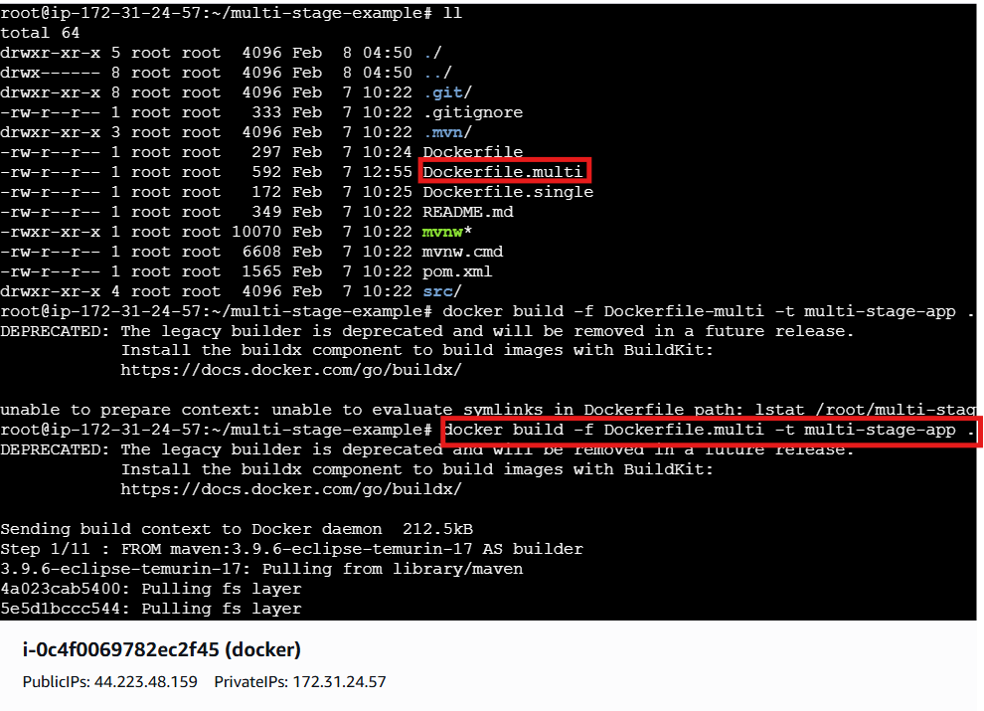
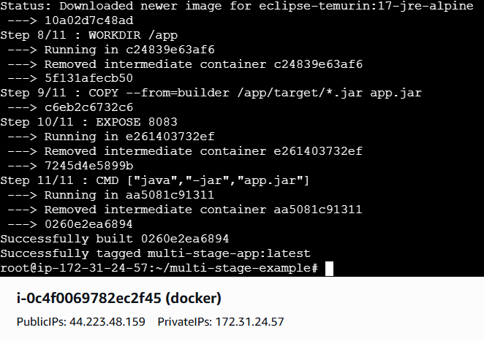

Run Container
docker run -d -p 8083:8080 --name multi-stage multi-stage-app
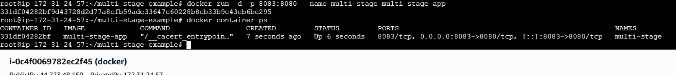
Validation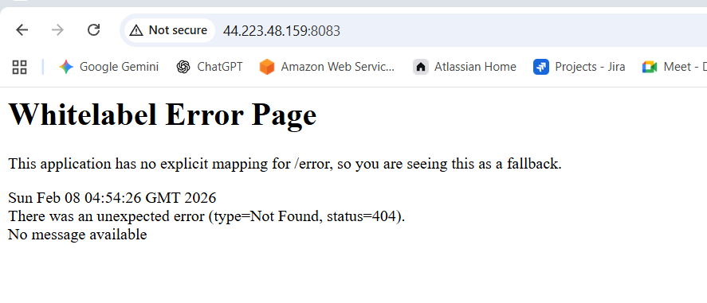
Conclusion
- Single-stage Dockerfiles are simple but result in larger images
- Multi-stage Dockerfiles remove unnecessary build dependencies
- Multi-stage builds are more efficient and suitable for production use

Install docker compose and execute sample application.
Objective
- To install Docker Compose on the system
- To understand how Docker Compose manages multi-container applications
- To run and verify a sample application using Docker Compose
Step by Step Implementation:
Step 1: Install Docker Compose
sudo curl -L https://github.com/docker/compose/releases/latest/download/docker-compose-linux-x86_64 \
-o /usr/local/bin/docker-compose
sudo chmod +x /usr/local/bin/docker-compose
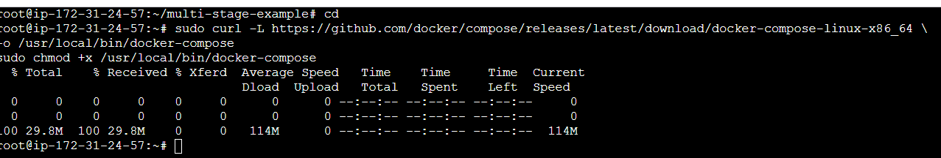
Step 2: Verify installation
docker-compose version
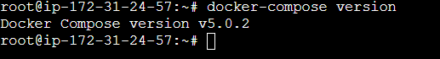
Step 3: Create docker-compose.yml
vi docker-compose.yml
Step 4: Add content
version: "5.0.2"
services:
web:
image: nginx
ports:
- "8085:80"
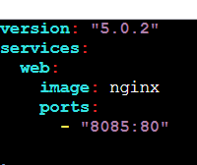
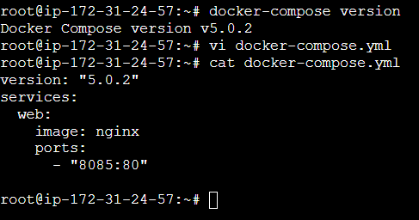
Step 5: Run application
docker-compose up -d
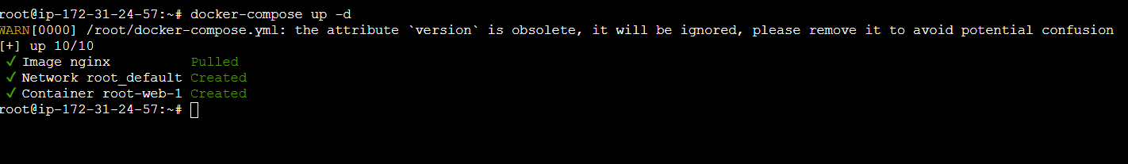
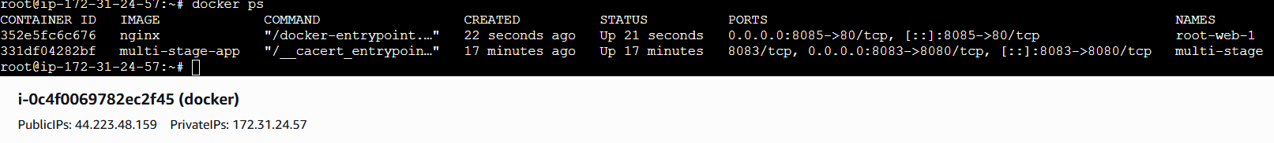
Validation
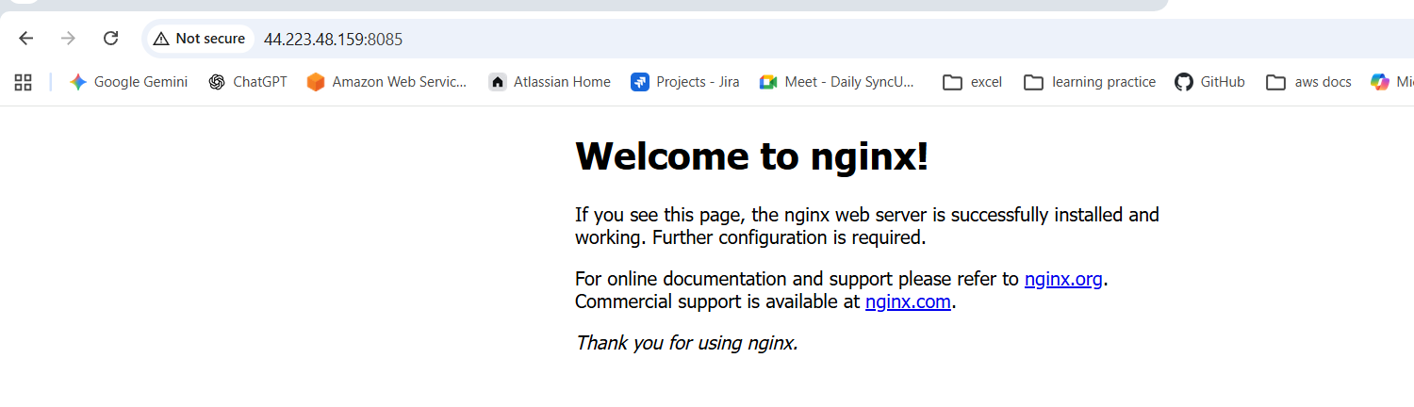
Conclusion
- Docker Compose simplifies application deployment
- Services can be started with a single command
- Docker Compose improves development and testing efficiency
Implement solution to scan images hen pushed to docker registry.
Objective
- To implement an automated solution for scanning Docker images
- To detect vulnerabilities when images are pushed to a Docker registry
- To improve container security in the CI/CD pipeline
Step by Step Implementation:
Step 1: Enable Image Security Scanning in Docker Hub
Log in to Docker Hub.
Navigate to:
Repositories → <username>/<repository> → Settings
Under Image security insight settings, select:
- Docker Scout image analysis (Recommended)
Click Save.
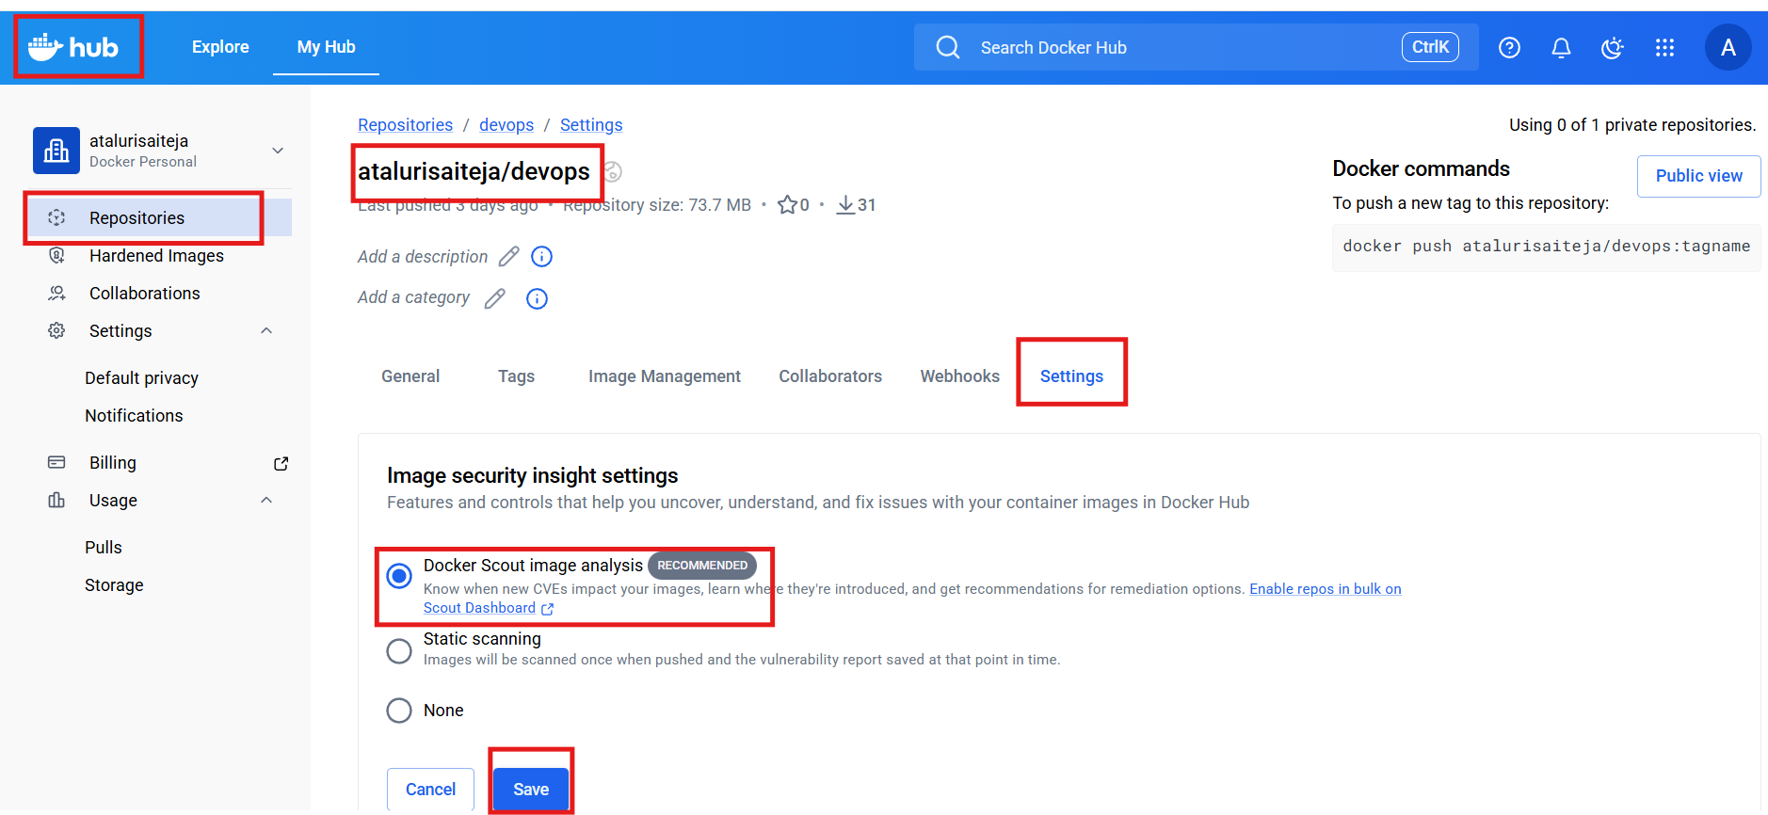
Step 2: Authenticate to Docker Hub from the CLI
Docker login
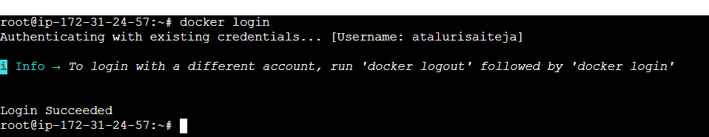
Step 3: Navigate to the Application Source Directory
cd multi-stage-example
ls -l
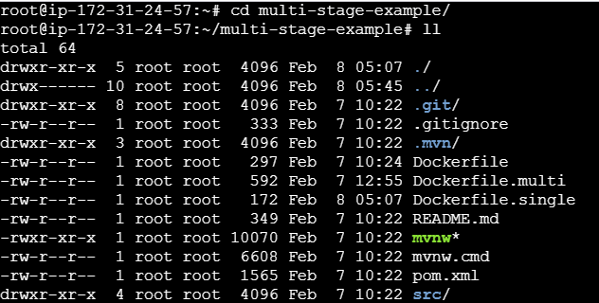
Step 4: Build the Multi-Stage Docker Image
docker build -f Dockerfile.multi -t multi-stage-app:latest .
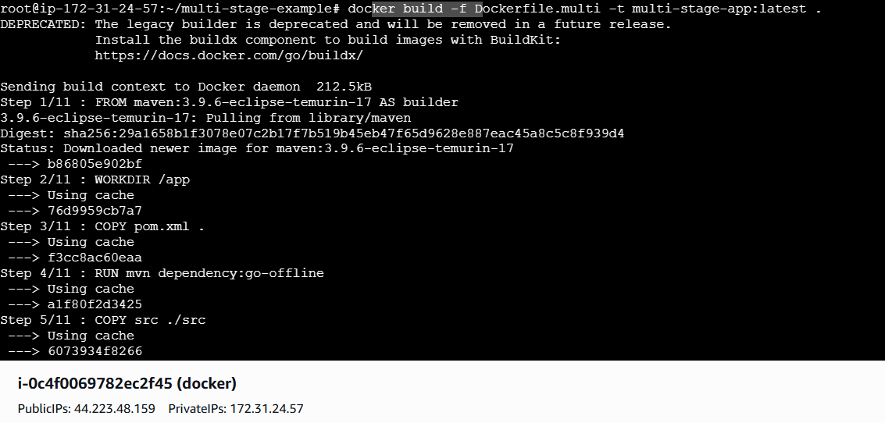

Step 5: Verify Built Images Locally
Step 6: Tag the Image for Docker Hub
docker tag multi-stage-app:latest <dockerhub-username>/devops:1.0
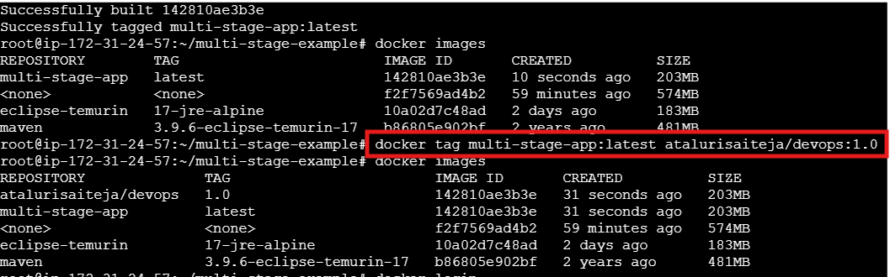
Step 7: install trivy and Scan the Image Locally with Trivy
Tool Used
Trivy (popular open-source container vulnerability scanner)
Download Trivy binary (latest stable)
sudo apt-get update
sudo apt-get install -y wget
wget https://github.com/aquasecurity/trivy/releases/latest/download/trivy_0.48.3_Linux-64bit.tar.gz
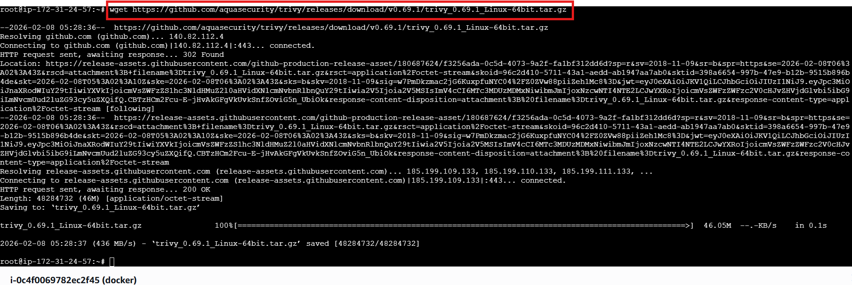

Extract it
tar -xvf trivy_0.69.1_Linux-64bit.tar.gz
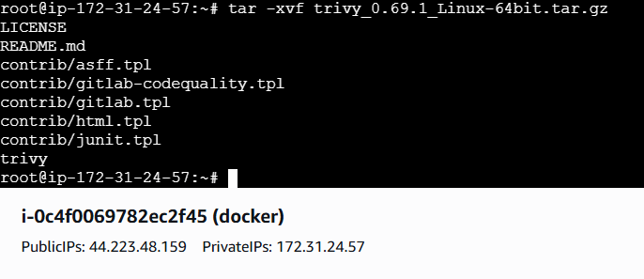
Move binary
sudo mv trivy /usr/local/bin/
sudo chmod +x /usr/local/bin/trivy
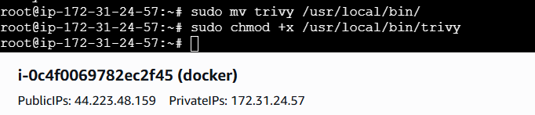
Verify installation
trivy --version
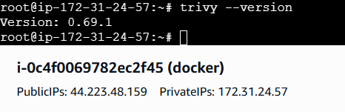

Now scan your Docker image
trivy image <dockerhub-username>/devops:1.0
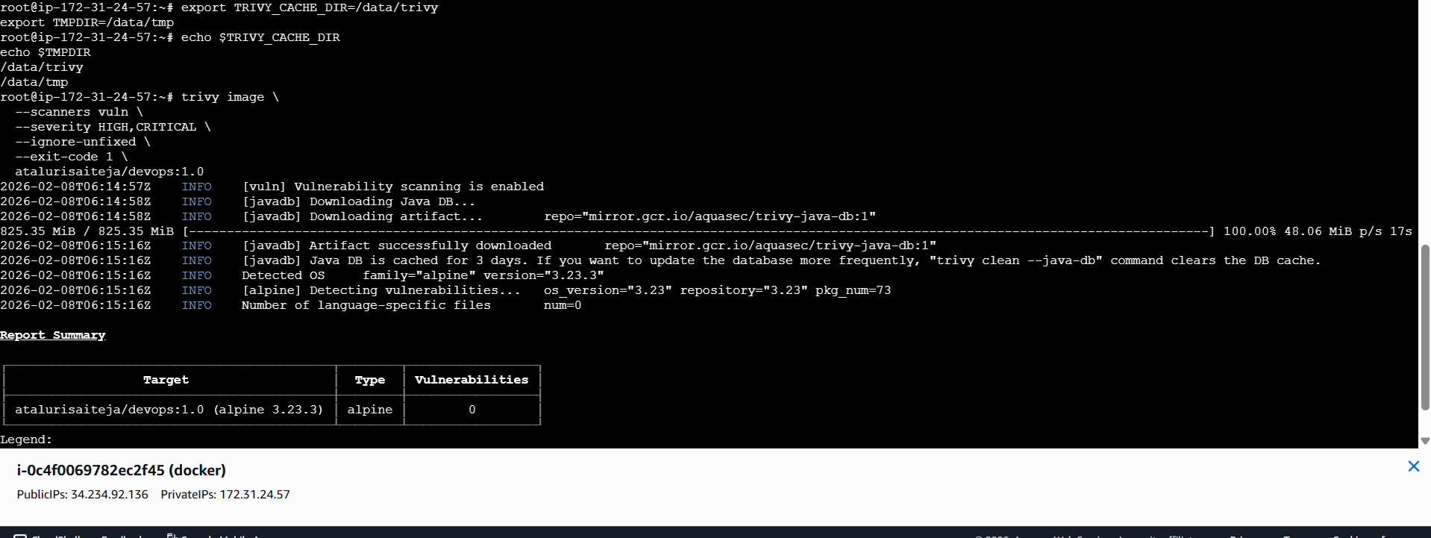
Step 8: Push the Image to Docker Hub
docker push <dockerhub-username>/devops:1.0
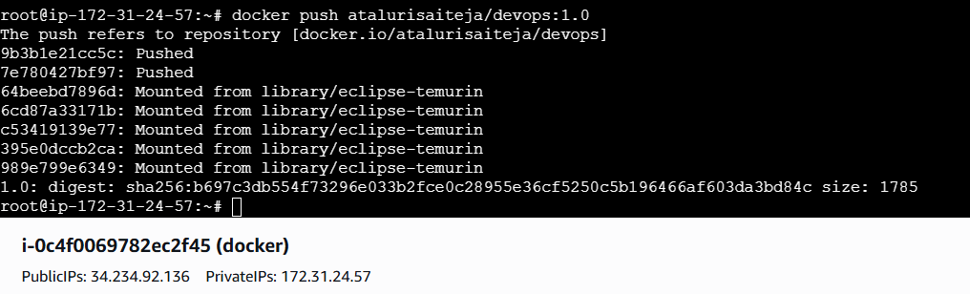
Step 9: Verify Image in Docker Hub Repository
Docker Hub → Repositories → <username>/devops → Tags
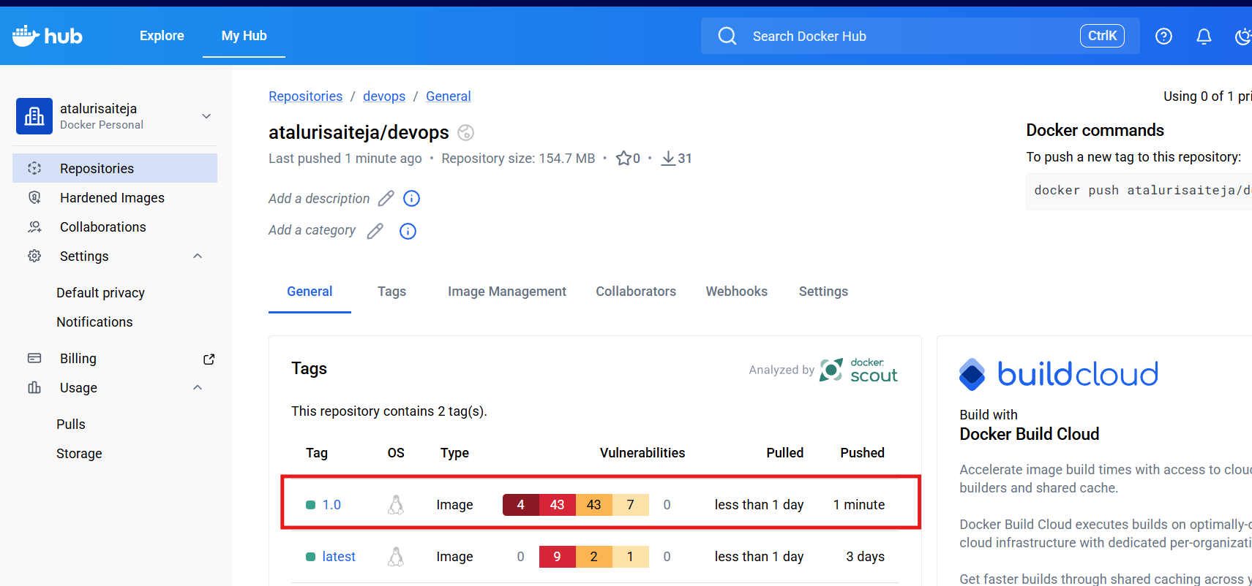
Conclusion
- Image scanning helps identify security vulnerabilities early
- Automated scans reduce the risk of deploying insecure images
- Integrating scanning with the registry strengthens overall container security

Implement solution to scan images when pushed to AWS ECR.
Step 1: Create or Identify an ECR Repository

aws ecr create-repository \
--repository-name devops \
--region us-east-1
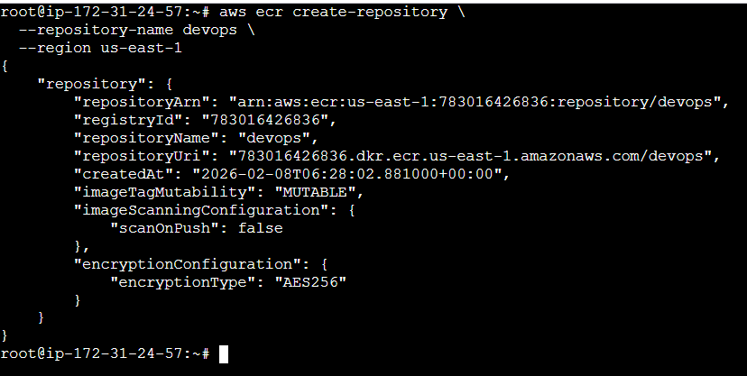

Step 2: Enable Image Scanning on Push
aws ecr put-image-scanning-configuration \
--repository-name devops \
--image-scanning-configuration scanOnPush=true
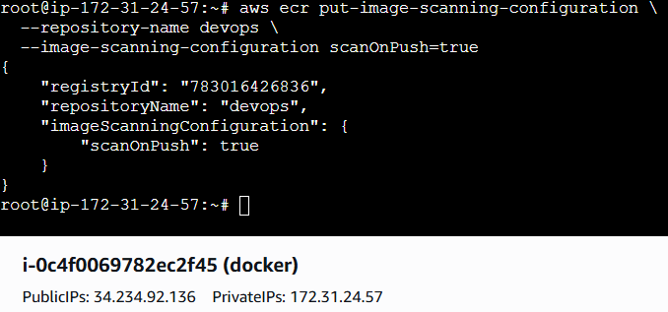
Step 3: Verify Scanning Configuration
aws ecr get-registry-scanning-configuration
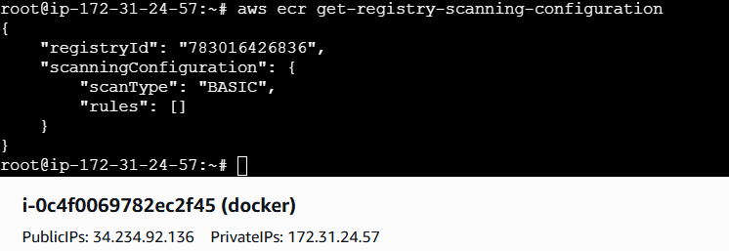
Step 4: Authenticate Docker to AWS ECR
aws ecr get-login-password --region us-east-1 \
| docker login \
--username AWS \
--password-stdin <account-id>.dkr.ecr.us-east-1.amazonaws.com

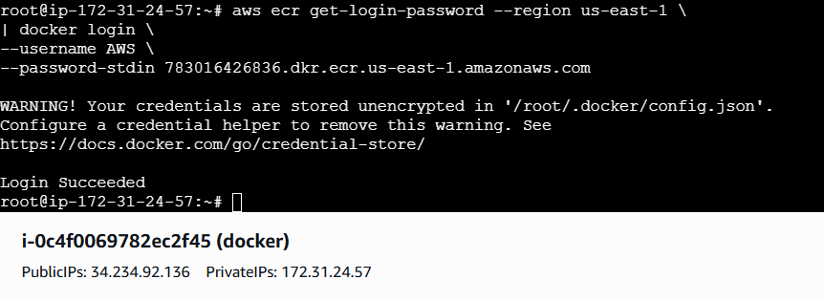
Step 5: Tag the Docker Image for ECR
docker tag multi-stage-app:latest \
<account-id>.dkr.ecr.us-east-1.amazonaws.com/devops:1.0
Docker images
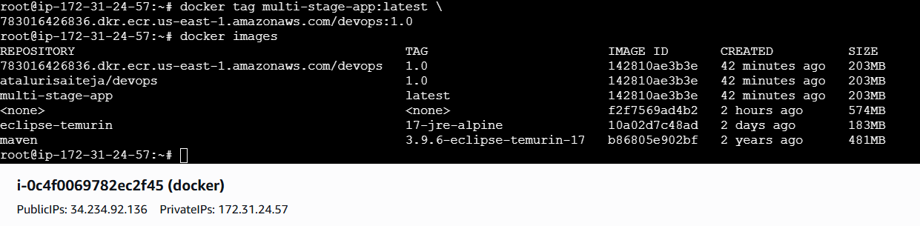
Step 6: Push Image to ECR (Triggers Scan Automatically)
docker push <account-id>.dkr.ecr.us-east-1.amazonaws.com/devops:1.0
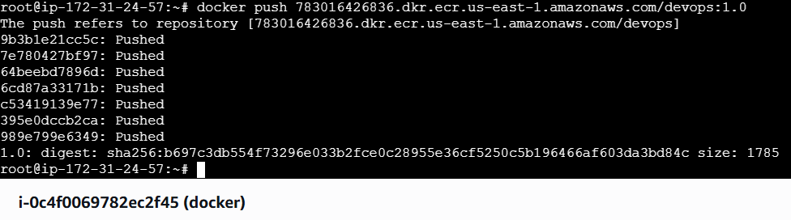

Step 7: View Scan Results in AWS Console
AWS Console → ECR → Repositories → devops → Images
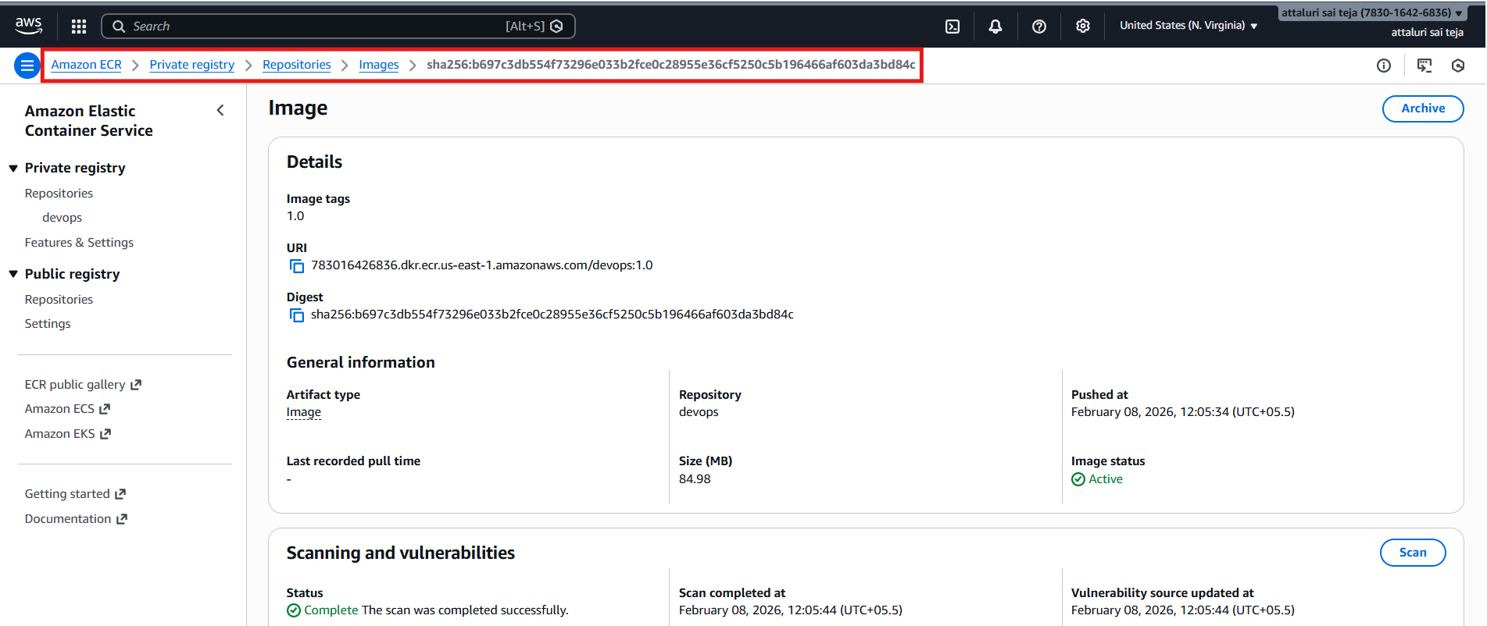
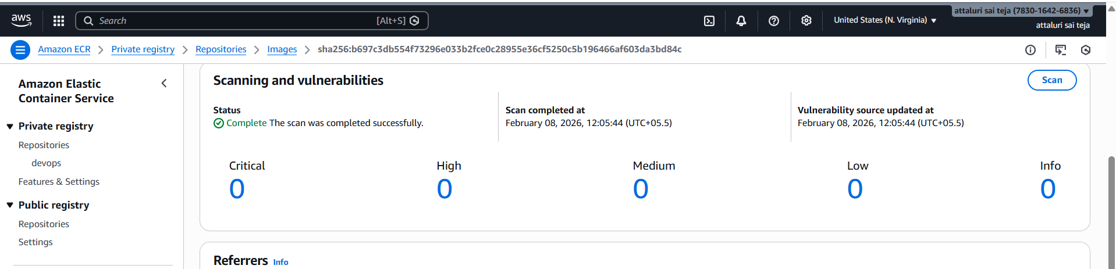
Step 8: Retrieve Scan Results Using AWS CLI
aws ecr describe-image-scan-findings \
--repository-name devops \
--image-id imageTag=1.0
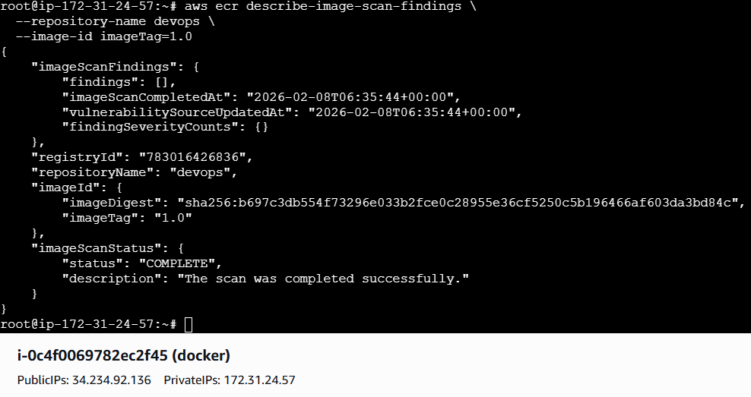

Create a Jenkins pipeline to create a docker image and push the image to Docker hub.
Prerequisites
1. Jenkins Agent Requirements
- Docker installed
- Jenkins user has permission to run Docker
docker –version
2. Docker Hub Credentials in Jenkins
- Go to:
- Jenkins → Manage Jenkins → Credentials
- Add Username with password
  - ID: dockerhub-creds
  - Username: Docker Hub username
  - Password: Docker Hub access token (recommended)
Step by Step implementation:
Navigate to Docker hub and click on profile > account settings> and create PAT
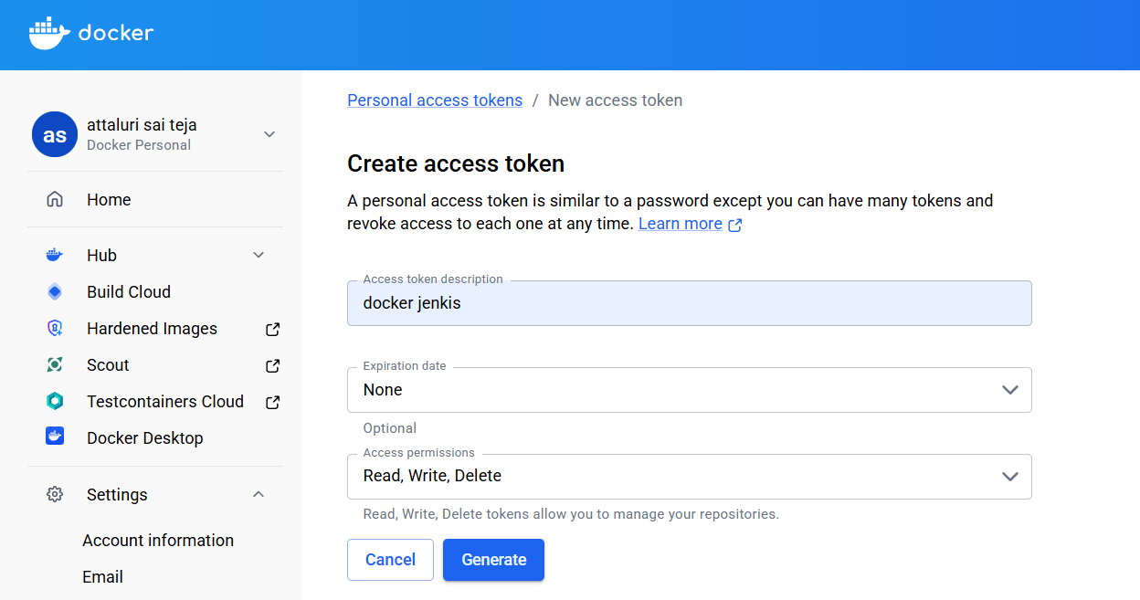

Copy the token and paste in Jenkins credentials
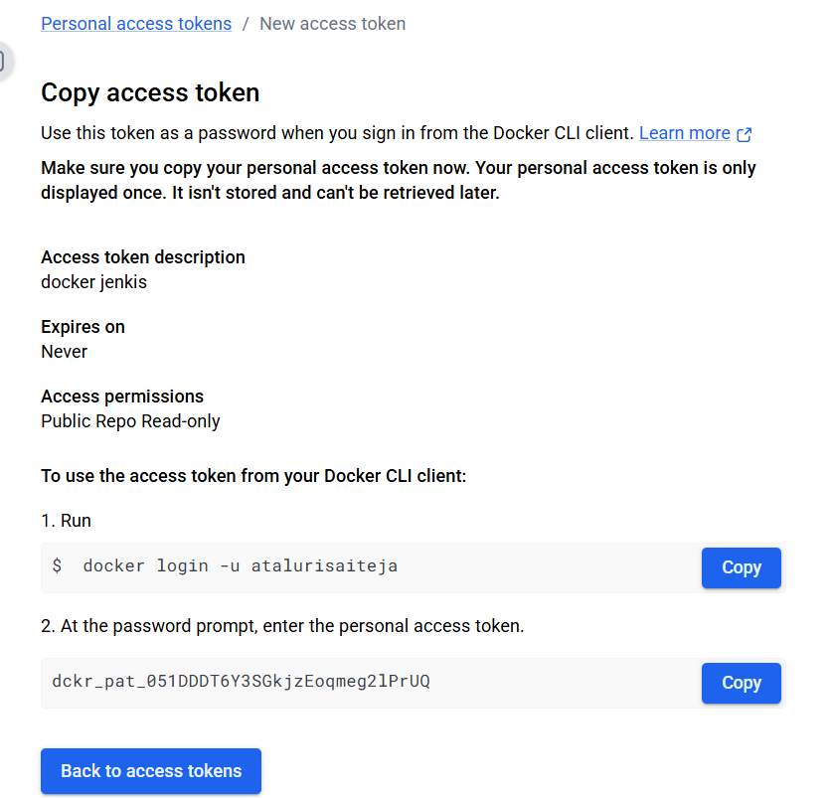
Step 2: Update Jenkins Credentials
- Jenkins → Manage Jenkins → Credentials
- Open the credential with ID:
- dockerhub-creds
- Update:
  - Username: atalurisaitja
  - Password: paste NEW TOKEN
- Save

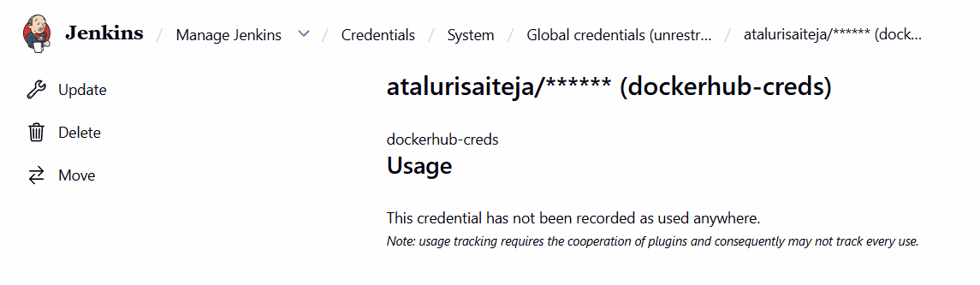
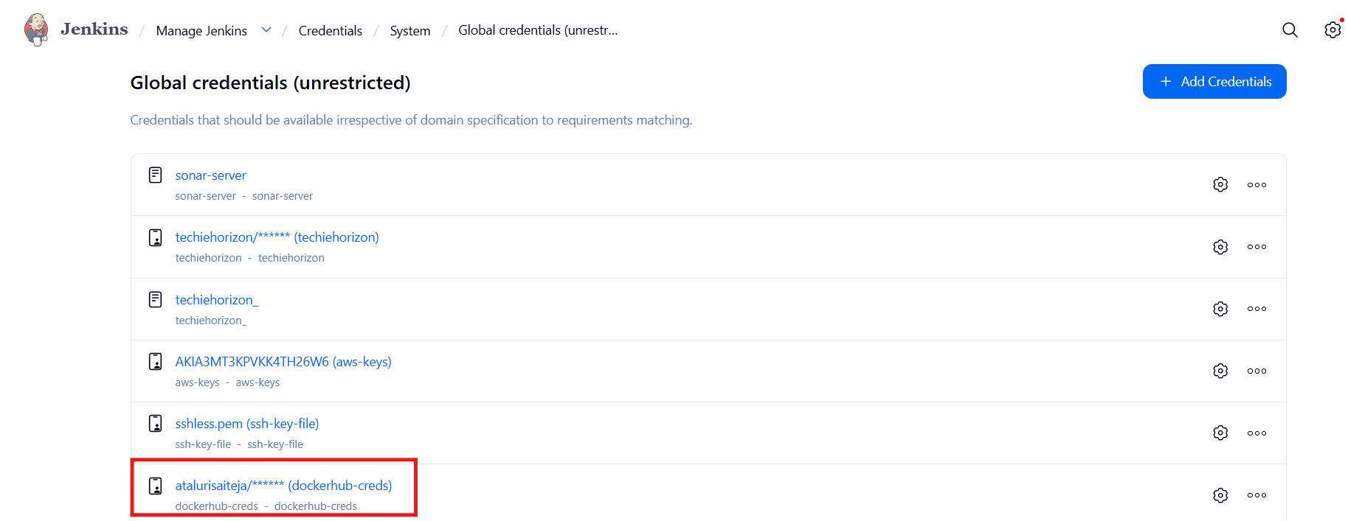
Step 3: install plugins of Docker
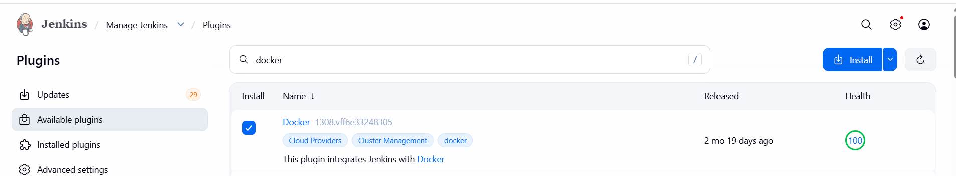
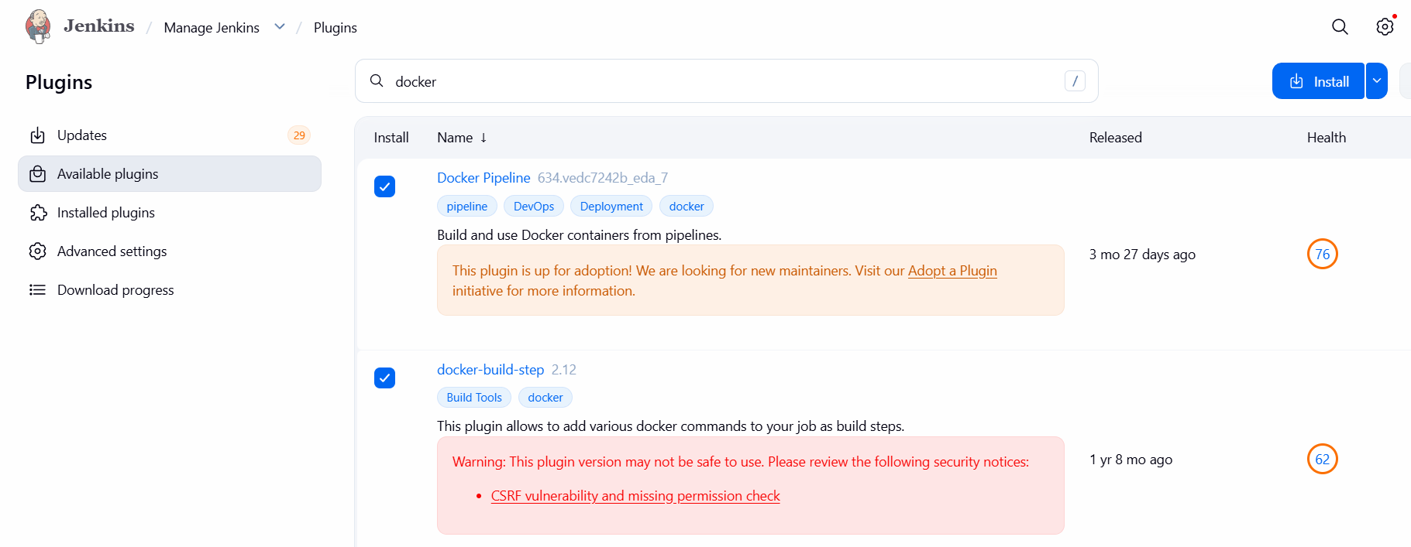

Step 4: Create a repository and add some files
Called
Add:
docker-pipeline/
├── Jenkinsfile
├── Dockerfile
└── index.html
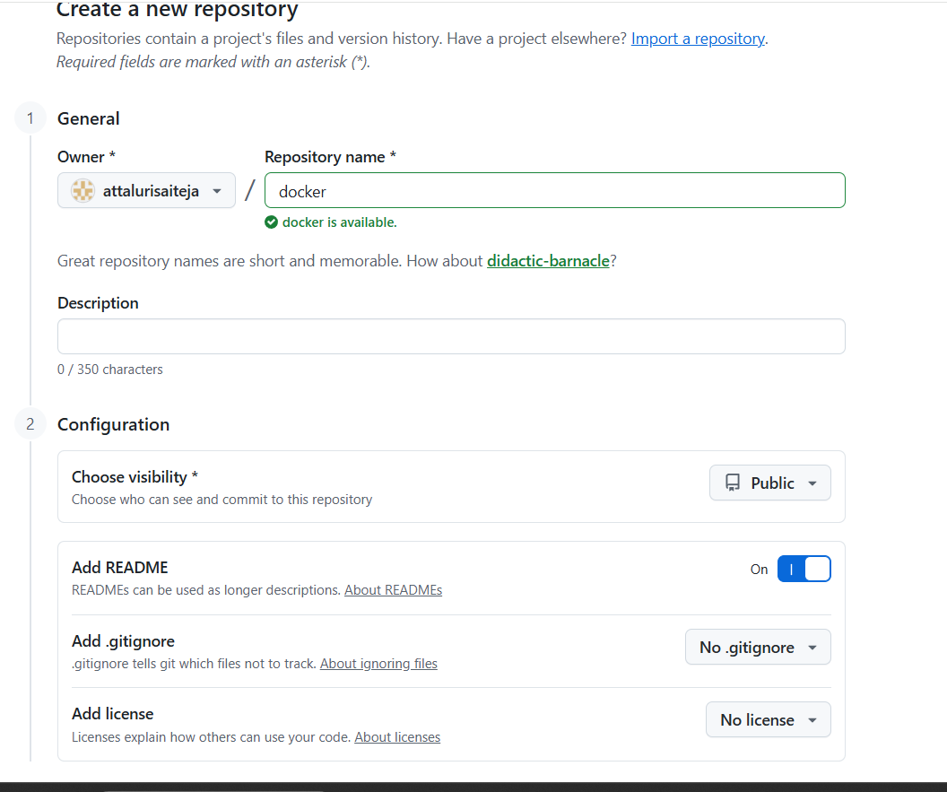

Create Pipeline
New Item → Pipeline → Name: docker_job1
—-> attach the repo url
Branch as main*
Save
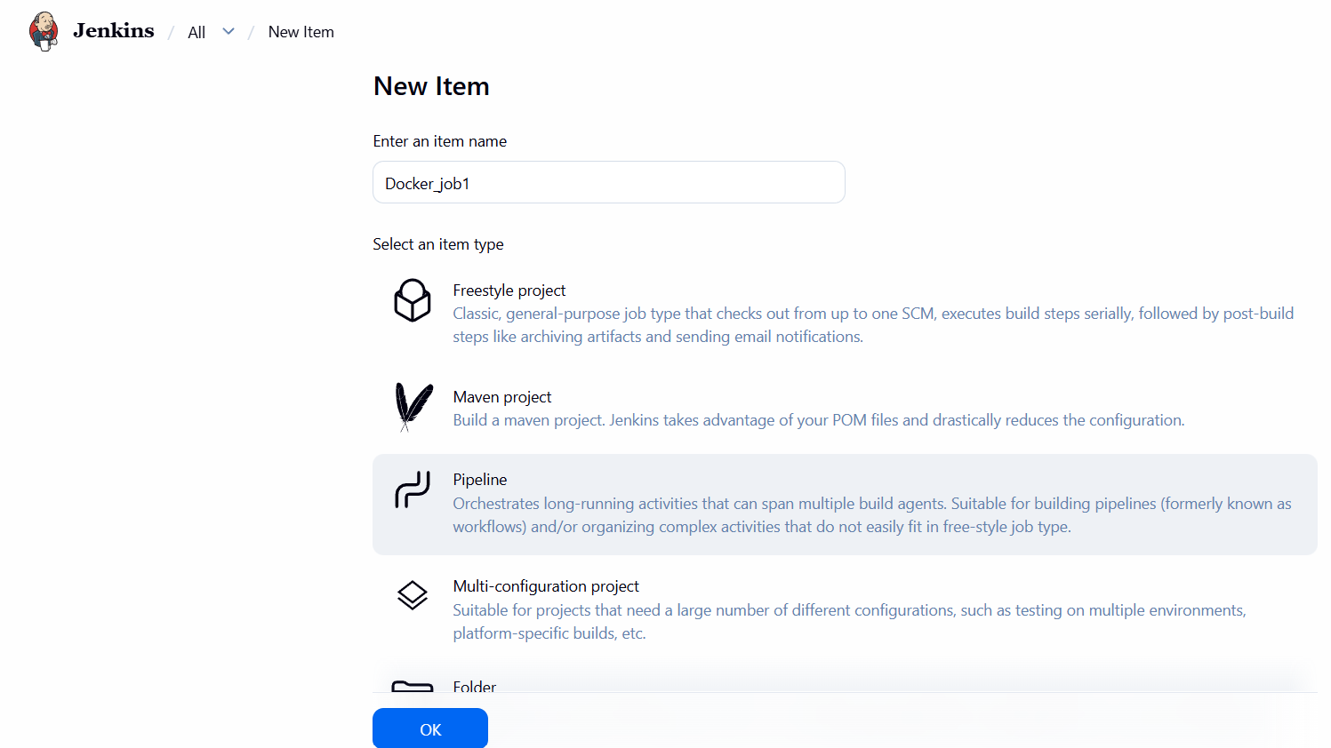

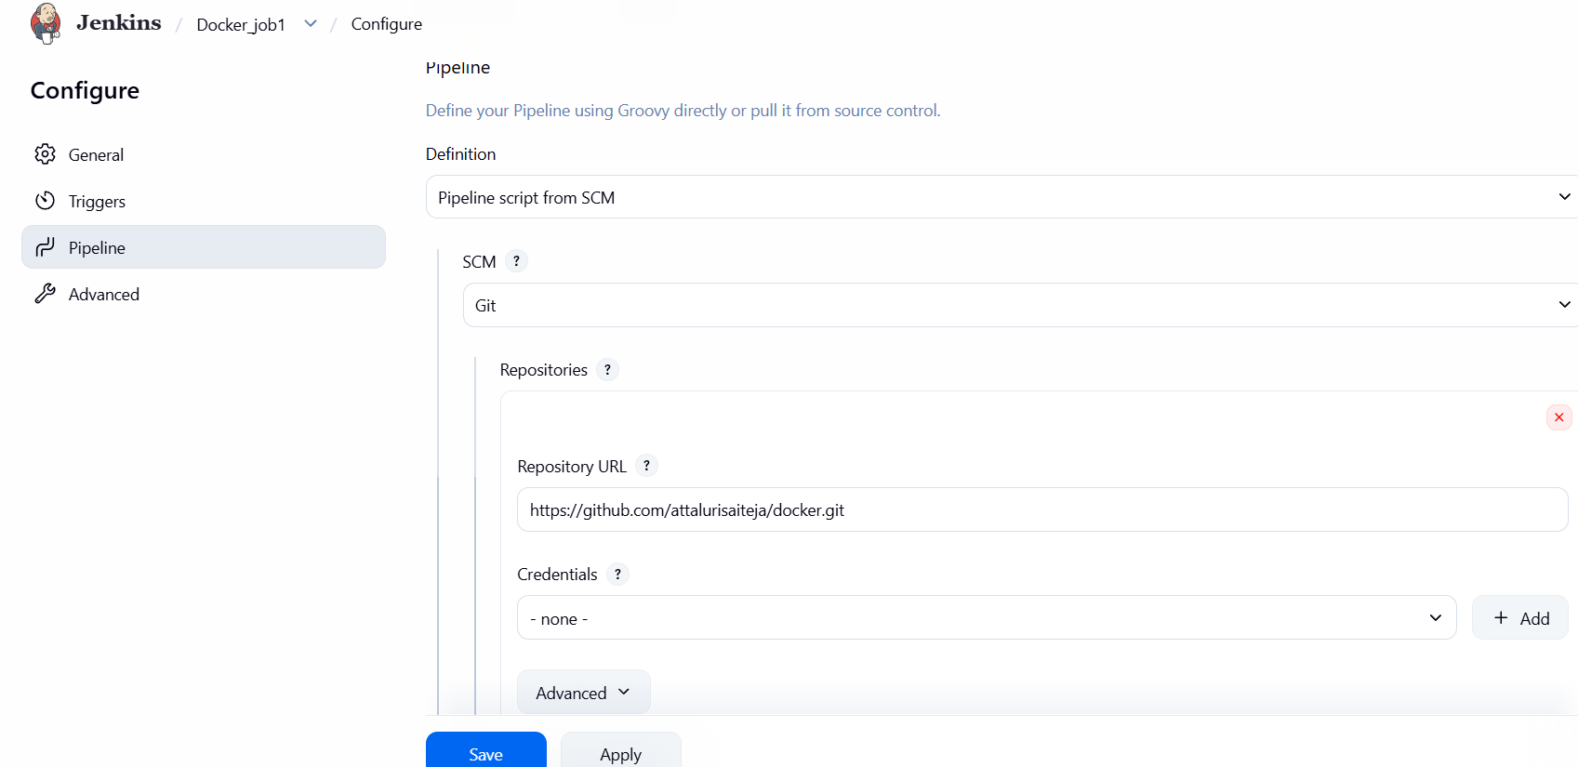

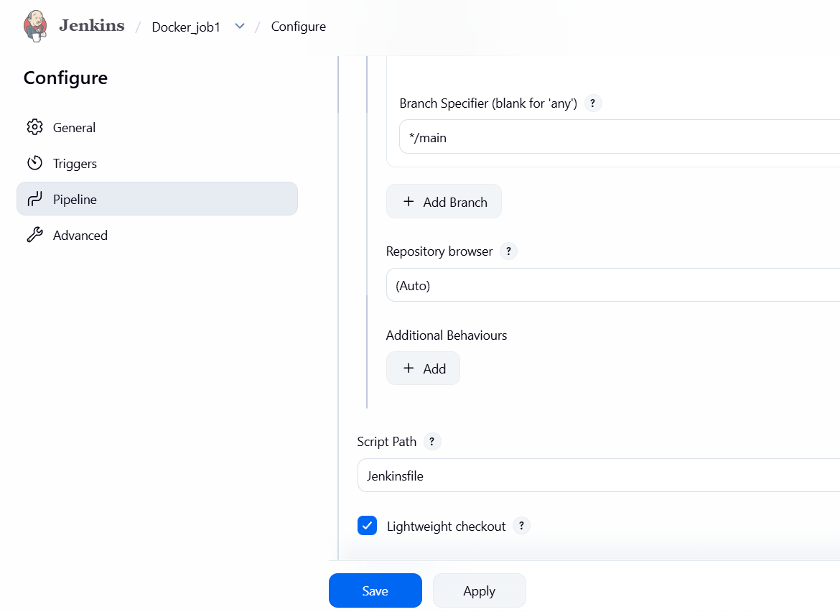
After that click on build
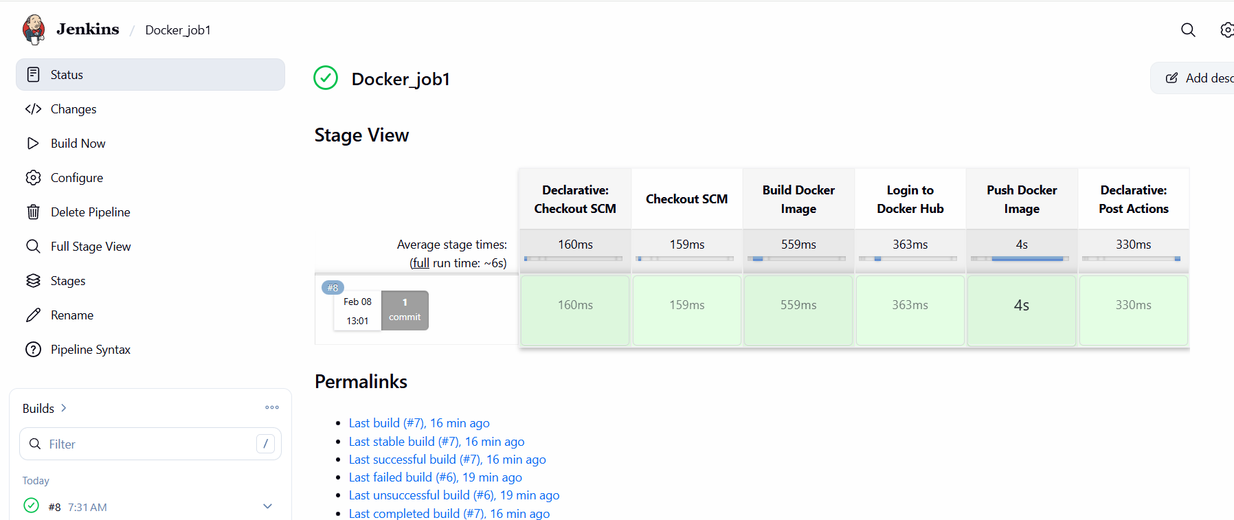

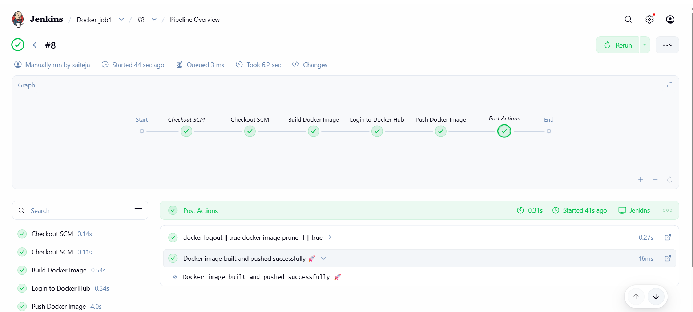
Validation:

- check your docker hub
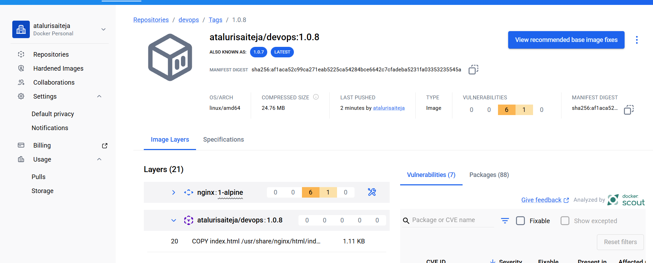

My git hub repo link::
https://github.com/attalurisaiteja/docker.git

Title:
Copy image from local machine to docker server and load the image.
Objective:
To transfer a Docker image from a local machine to a Docker server and load it there so the image becomes available for running containers on the server.
Open gitbash in desktop
Then pull image here (Make sure u have signed in to uer desktop docker account )
docker pull nginx
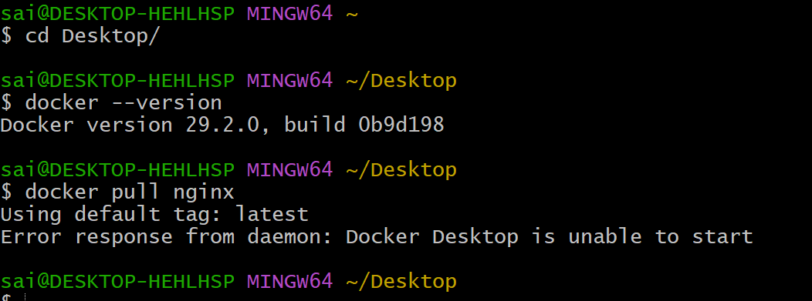
Conclusion:
By saving the image locally, copying it to the Docker server, and loading it into Docker, the image is successfully made available on the server without needing to pull it from a remote registry

